**Sqlite3 Database Connection with Python**

**Open Google Browser**

**---> Search**

**--->db browser for sqlite**

**Click on** [**https://sqlitebrowser.org**](https://sqlitebrowser.org)

**--> Click on Downloads**

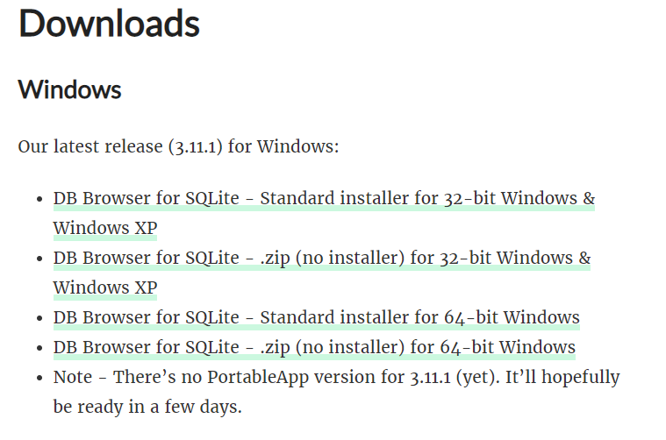

**Select 32 or 64 depending upon your system configuration.**

**Download and Install.**

**Please select only DB Browser (SQLite) as seen below**

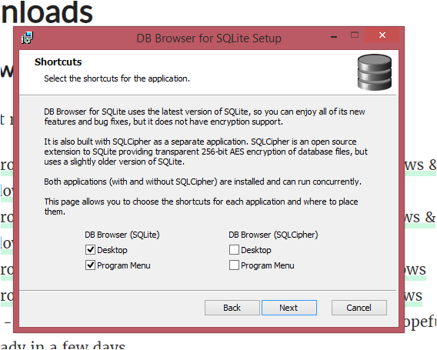

**You will C Icon as shown in the below on the Desktop**

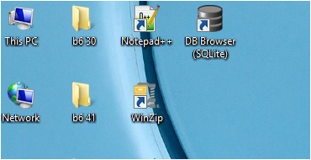

**Double Click on the DB Browser (SQLite)**

**You can C SQLite Browser as Follows….**

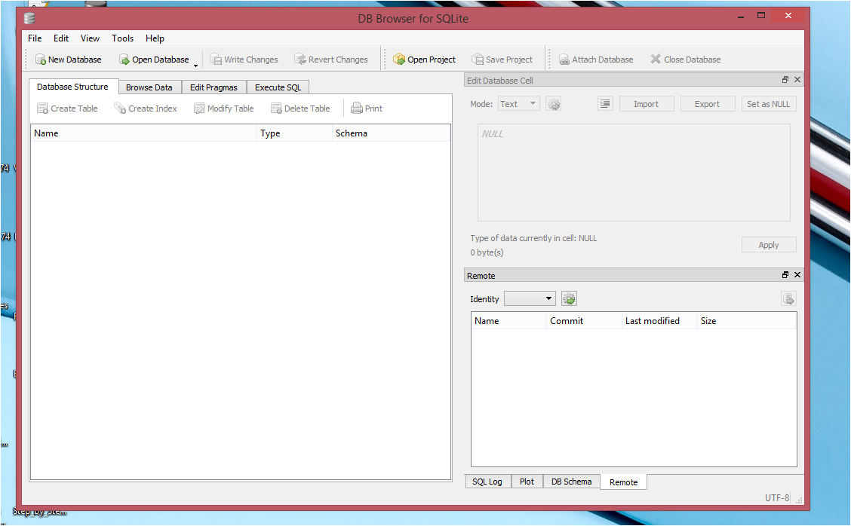

**Now Create “SQLite3 Database Connection” with Python**

**Create new “name”.py File….**

**Copy this Code in Python IDLE in Our Project we Use PyCharm.**

**Code:**

**Import Sqlite3**

**db = sqlite3.connect(‘sample.db’)**

**cr = db.cursor()**

**cr.execute(“create table login(user text, password text)”)**

**db.commit()**

**db.close()**

**print(“Successful Created DataBase….”)**

**Explanation of the above Code.**

**First of all we need to Import Sqlite3 module**

**We will use connect Function in order to Create New Database, if database not exists it will create Database otherwise it will create connection to that database.**

**We will pass parameters inside that Connect Function which will be database Name what we going to use in our Project.**

**db is an Variable (Object) we are creating**

**cursor is the Method return object**

**That cursor variable(object) will call method to Execute**

**Which is in cursor will execute that Command**

**db.commit() method will saves whatever changes done in our database.**

1. **To use the SQLite3 module we need to add an import Statement to our Python:**

**Import Sqlite3**

1. **To connect to the database, we can use sqlite3. Connect function by passing the name of a file to open or create it :**

**db = sqlite3.conect(‘sample.db’)**

1. **Once you have a connection, you can create a cursor object and call its execute() method to perform SQL commands.**

**cr = db.cursor()**

1. **Create table**

**cr.execute(‘Create table login(user text, pass text)’)**

1. **Save (commit) the Changes**

**db.commit()**

1. **Connection Close**

**db.close()**

**This method closes the database connection:**

**If you just close your database connection without calling commit () first, your changes will be lost!**

**After running this database connection database will be created in the same Folder where your project resides.**

**Go to browser ->db browser for sqlite -> sqlitebrowser.org**

**Choose 32 or 64 bit depending upon your system**

**Install after it downloaded in your system**

**Open Windows -> Open where database is present**

* **Open in SQLite. Browser**
* **How to Insert Record(s) in SQLite3 Database:**
* **Save this Code in “name”.py name as u wish**

**and run the program.**

**Code:**

**import sqlite3**

**db=sqlite3.connect(‘sample.db’)**

**cr=db.cursor()**

**cr.execute(“insert into login(user, password) VALUES (‘aaa’, ‘111’’’)**

**db.commit()**

**db.close()**

**print(“Successfully Record Inserted….”)**

* **How to display values in Database:**

**import sqlite3**

**db=sqlite3.connect(‘sample.db’)**

**cr=db.cursor()**

**x= “ccc”**

**y=”3232”**

**cr.execute(“insert into login(user, password) VALUES (‘x’, ‘y’,’’)**

**db.commit()**

**db.close()**

**print(“Successfully Record Inserted….”)**

**Output :**

**It will Directly Insert “x” and “y” in the User and Password**

**How to take INPUT Values given from the Keyboard and Insert into the Database:**

**Code :**

**import sqlite3**

**db=sqlite3.connect(‘sample.db’)**

**cr=db.cursor()**

**x= input(“Enter User Name:”)**

**y= input(“Enter Password:”)**

**cr.execute(“insert into login(user, password) VALUES**

**(‘ ”+x+” ’, ‘ “+y+” ’)’’)**

**db.commit()**

**db.close()**

**print(“Successfully Record Inserted….”)**